**Overview of GUI components**

**Projects**

**Purpose:**

Each “project” will present a different “whole”.

When a customer builds a new survey – he creates a new “project”.

Just like a coding project.

**Blocks**

**Purpose:**

In every project, we’ll hold a list of blocks. Each block will hold a bag of ordered questions.

The blocks will allow a user to save a successful set of question along with their options and settings.

**Questions**

**Purpose:**

In every block we hold an infinite list of question.

Every question will provide the maximum level of customization.

Each question will have the following basic set of setting:

* Type of question (multiple choice, graphic, etc).
* Position of answers.
* The question’s text position.
* Ordinal value according to the order in the block.

Note that the user should be able to copy an existing set of question’s setting.

**The *Preview* mode**

**Purpose:**

To allow the user to see the survey the same way the subject will see it, without generating new raw data.

**The analysis view**

**Purpose:**

This view will provide the users possibility to examine all recorder data.

Along with some graphical view that’ll be appealing to the eye.

**The survey flow view**

**Purpose:**

This view will allow the user to observe his survey as a whole, and get comfortable summary of his survey structure.

**Cool nice to haves**

**Purpose:**

Awesome features that might turn our system amazing.

**Overview of graphical features**

***The following section will describe the optimal structure of the graphical interface, along with examples from Qualtrics.***

***Please keep in mind that the images are just for conception understanding purposes.***

**The “projects view” page:**

* 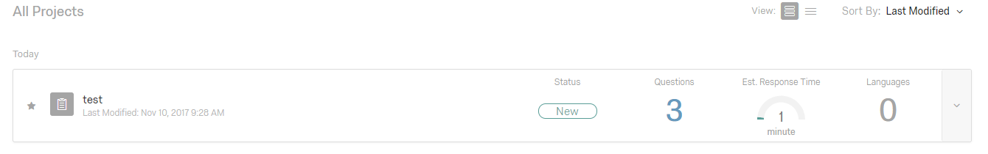Each project will be viewed as a record.

For each project record we’ll present the following info:

* Status (New \ Active \ Finished).
* Questions (number of them).
* Filled copies (by different users).
* Last modified date.
* Last date the survey was filled.

**The “blocks view” page:**

**Required features –**

* The user can collapse any block (the actual view of it’s data) at any given time.
* All of the projects blocks will be presented as a list.

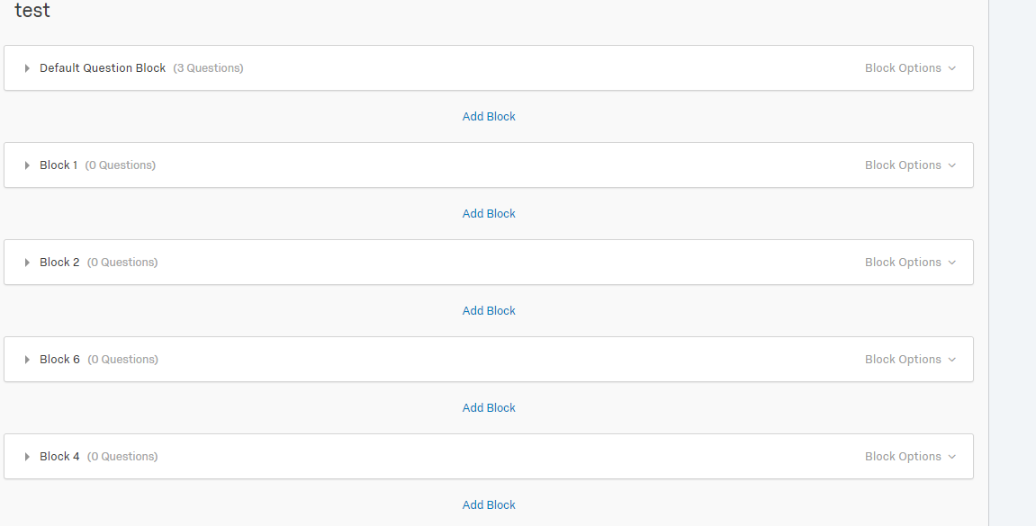

* Each block will have a visible list of questions objects.
* 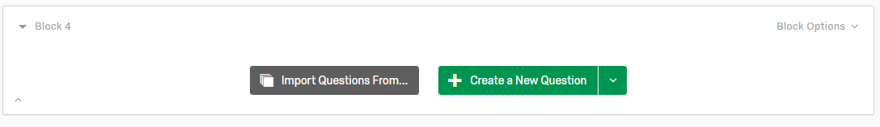Each block will have a central button – “add a question”.
* Each block can be renamed.
* Each block will present the number of questions it contains.

**Required tools and mechanisms –**

* The ability to change a block’s position in the projects layout.
* Each block will have an options list that’ll contain:
* The ability to *save* a *block setting*.
* The ability to *save* a block’s *list of questions.*
* *Import* setting \ questions from a saved block.
* Move a block up\down in the project’s layout.
* Delete a block.

**The “Question unit” view:**

**Required features –**

* The user can change the question’s setting (detailed below) at any given time.
* Each text that need to be filled in a question will have a default “click to write question\answer” phrase.
* 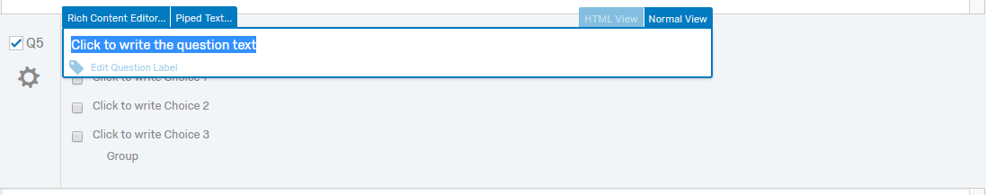When a user clicks to edit the text of an answer or a question , it’ll update and immediately and undependably from other fields.
* Each question can be renamed (other than having an ordinal label).
* Each question will have the following “must have” settings:
* Question type.
* Question text position.
* Answers position.
* Validation options.

Question type

The possible question’s types will be –

* Multiple choice question.
* Rating questions (choose the correct column by their description , “always” / “sometimes” etc’) .
* Free text question (provide a text box to be filled as an answer).
* Drill down questions (select the correct option from a menu that opens when’s clicked).

Each type should have it’s own options and limitations (a multiple choice should have an answer limit).

**Notice** that the question type also determines the kind of answers!

Question position

The position of the question’s text. We’ll allow the following:

* (a) Upper middle position (default).
* (b) Upper left corner.
* (c) Upper right corner.
* (d) Middle middle position.
* (e) Middle left position.
* (f) Middle right position.
* (g) Lower middle position.
* (h) Lower left corner.
* (i) Lower right corner.

Answers position

The position of the available answers.

* Multiple choice questions options:
* A vertical list (default).
* A horizontal list.
* A square matrix.
* Around the question (just for question position d ).
* Rating question: none.
* Free text questions:

All positions apart from the question’s position (a-i).

* Drill down questions: *same as multiple choice questions.*



Validation options

For each question we’ll provide the option to add a *skip* button, or forcing the subject to select an answer before enabling the *next question* button.

**Required tools and mechanisms –**

* Each question will provide the option to change it’s position in the block’s questions list.
* Each question will have a *delete* button.
* The user can add *tags* to a question. (might be used when filtering or searching).

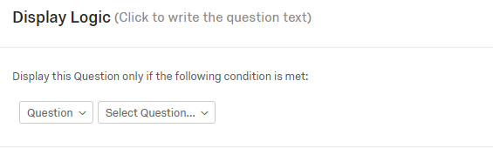

**The preview mode**

**Required features –**

* The user should be able to play an authentic simulation on the survey, with the following exceptions:
* The user can exit the mode at any time.
* Data will NOT be collected and passed on to the analysis.

**The analysis view**

**Required features –**

* The analysis view will have a few different tabs-
* The “raw data” tab.
* The graphical tab.

Raw data tab

The tab will present every answer and question as a listing , the columns for every entry will be:

* Question text.
* Selected answer (number and text).
* Block source.
* Date answered.

Graphical tab

This tab will present selected info in the formation of charts , piecharts , etc’.

The different info TBD.

**Required tools and mechanisms –**

* The major mechanism should be the *filtering* mechanism , allowing the user to filter the raw data according to:

Date , question type , block ,times the answer was selected , and more.

The exact list – TBD.

* The analysis view should have a predefined templates that’ll define our graphical capabilities.

(what kind of ways to present the data we want).

**Survey flow**

**Required features –**

* Allowing the user to move his view by dragging the mouse.
* Change blocks order.
* Appealing graphic signs of continuity between blocks.
* The option the duplicate and delete a block.
* The option to change each block bubble color.
* Presenting beside the blocks name info such as:
* Number of questions.
* Number of different types of questions.
* Name.

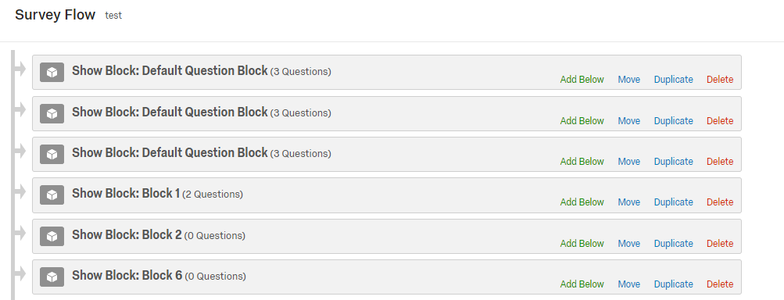

**Cool nice to haves**

* Enabling different tools to activate on a block/question.

Such as spelling check, translation, and more.

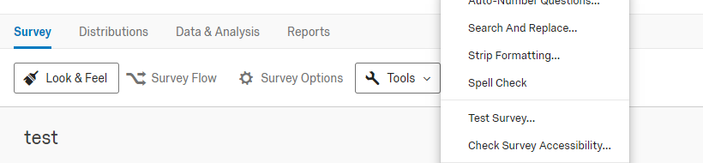

* Add “meta” options for each survey.

Such as dates to be active , choose communication method , and more.

* Sharing options. Enabling the user to share his survey through online platforms.

